We are going to start with the Bird database and build a Win Forms App around it.

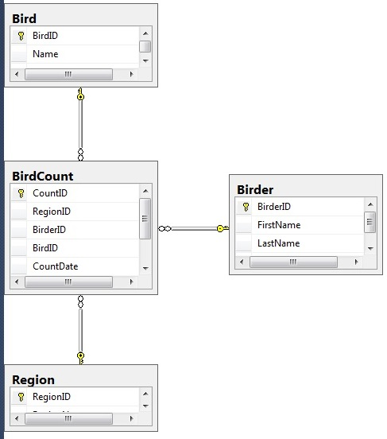

The first thing we need is to add a datagridview to a form that displays the contents of the BirdCount table. Your form load method should call a private method to display the data, since we will want to use that code in other parts of the program.

Next we want to add capability for a user to add a new event sighting. To do an insert into the BirdCount table, the user needs to specify a RegionID, BirdID, BirderID, date, and count. To avoid user errors and corrupt data, we should use drop down lists to allow them to specify the RegionID, BirdID and BirderID. Then we need a text box for the date and count.

We will start with just a RegionID choice, and we will hard code the BirdID and BirderID in our updates to verify that it works. Then we will go back and add the 2 dropdowns.

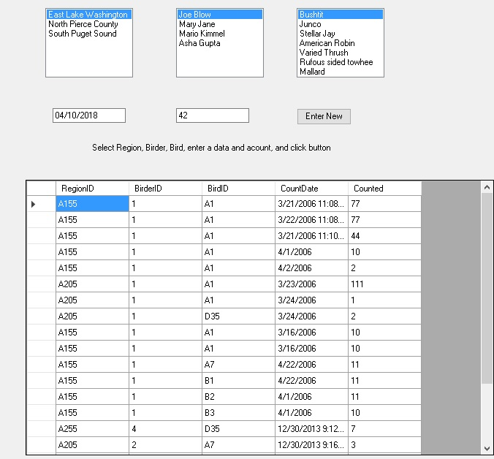

Lastly, we will add 3 buttons, each one will open a new form, and allow the user to add a new Region, BirdID, or BirderID.